Teaching with Zoom in

a Classroom on Campus

Customize this section based on available equipment in room -------------------------------------------------------------

Step 1: Set Up the Podium Computer and Projector
The podium computer allows you to utilize the in-room microphone and speakers as well as hard-wired internet for a stable connection.

NOTE: If you choose to use your own laptop or device, the in-room audio will not work.

- Log in to the podium computer using your Penn State WebAccess ID (abc123) and password.

- Push the power button on the Crestron podium control system, if necessary.
NOTE: There are two Crestron control system options, a white pod with a touch screen or a black pod with hard buttons.

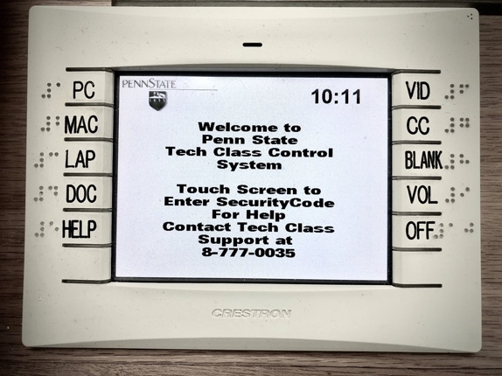
Crestron, white pod with touch screen
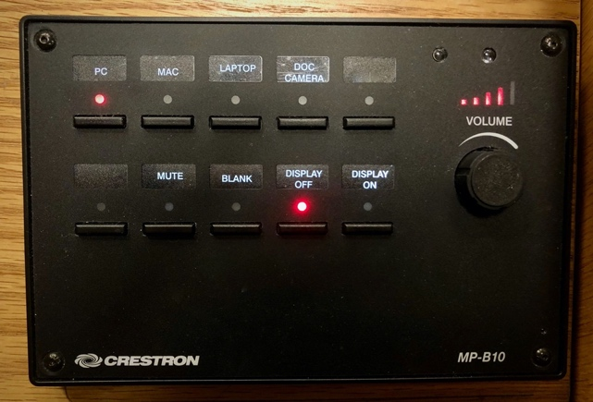
Crestron, black pod with hard buttons

- Click the PC button to connect the podium computer to the projector.
NOTE: Always use the PC button to connect to the in-room microphone and speakers.

- Ensure the webcam is plugged into the USB ports on the podium computer desktop tower or the USB ports near the monitor, so that students can see your video.
NOTE: A webcam can also be used in place of a microphone.
End customization ------------------------------------------------------------------------------------------------------------------------

Step 2: Log in to Zoom and Teach
You can use this method to teach live with students in this room, with students who are attending remotely, or both. You can also remove the chat and participant components and use this method to record your instructional content from this room without students.

NOTE: Before you begin, ensure all content is accessible online or [customize] and adjust all
Zoom meeting settings at zoom.psu.edu.

- Click to open the Zoom App from [customize].

- Log in to Zoom “with SSO” using your Penn State WebAccess ID (abc123) and password, if prompted.

- Click Join and enter your Meeting ID.

- Locate the Zoom tool bar and prepare your meeting, as needed:
  - Click the up arrow to the right of the Unmute (microphone) and select Test Audio
  - Click Unmute (microphone) to unmute your audio
  - Click Start Video (video camera) to share your video
  - Click Chat to open the chat
  - Click Participants to open the list of participants
  - Click Share Screen to share your desktop, a window, or an application with students
  - Click Record and select Record to the Cloud to access in Kaltura and Canvas
Zoom toolbar

- Instruct all students to:
  - Log in to your Zoom meeting
  - Ask and answer all questions in chat
  - Mute microphones (in person and at home students)
  - Mute device speakers (in person students only)

- Teach the class and refer to chat throughout for questions.

- Click the Stop Recording button at the end of your class.

- Click the Log out button on the Podium Computer to ensure you are properly logged off.

- Locate recording in your Media Gallery in Canvas or Media Space in Kaltura after sufficient processing time.

Faculty and Staff who need immediate assistance should [customize].

